Plan Set up guide
GLM Setup Guide

VibeHack Workshop Handbook
This handbook assumes you've already installed Claude Code in your terminal and downloaded Cursor. From here, all you need to do is point both tools at the GLM Model. Every command, URL, and model name is kept exactly as-is, so you can copy and paste directly.
🚀 A note before you dive in
We're genuinely thrilled to have you building with GLM. For us, the best part of a hackathon isn't only the teamwork; it's the pressure of the clock. That tension is exactly what pushes you to take a small idea and grow it into something real, watching it scale from small to big in a remarkably short window of time. We're glad to witness that happen, and even gladder to be part of it alongside you. Now go build something.

First things first: get your GLM API Key from Discord
Both tools need the same GLM API Key. For this class, keys are handed out in the GLM / Z.AI Discord chat group:
- Join / open the GLM-related Discord group (invite link shared by the Vibehack Discord).
- Find the pinned message or the dedicated key channel and follow the steps to claim your key.
- Copy and save the key — both tools below will use it.
- Stuck? Ask in the group

Get Your API Key:

https://zai-hackathon.zeabur.app/

If you are not using claude code or cursor, find the official devpack: https://docs.z.ai/devpack/tool/others

Claude Code

GLM + Claude Code
Claude Code talks to GLM through a set of Anthropic-compatible environment variables.
The flow is simple: get a key → point Claude Code at Z.AI → launch.
Could refer to more details instruction: https://docs.z.ai/devpack/tool/claude

Step 1 · Get your GLM API Key
First things first: get your GLM API Key from Discord and here: https://zai-hackathon.zeabur.app/

Both tools need the same GLM API Key. For this class, keys are handed out in the GLM / Z.AI Discord chat group:
- Join / open the GLM-related Discord group (invite link shared by the Vibehack Discord).
- Find the pinned message or the dedicated key channel and follow the steps to claim your key.
- Copy and save the key ; both tools below will use it.
- Others? Ask in the group

Step 2 · Confirm Claude Code is ready
You already have it installed, so just check the version. The team has verified v2.0.14 and above; update if you're behind.
TERMINAL
# check version
claude --version

# update if needed
claude update

⚠️ Environment requirements
Claude Code needs Node 18+. macOS users should install Node via nvm to avoid permission issues; Windows users also need Git for Windows.

Step 3 · Point Claude Code at GLM
You're telling Claude Code two things: which key to use and which server to call. Pick whichever method suits you.
Manually (any OS)
Open ~/.claude/settings.json, add the env block below, replace your_zai_api_key with your key, save, and open a new terminal window.
~/.CLAUDE/SETTINGS.JSON
{
"env": {
"ANTHROPIC_AUTH_TOKEN": "your_zai_api_key",
"ANTHROPIC_BASE_URL": "https://api.z.ai/api/anthropic",
"API_TIMEOUT_MS": "3000000"
}
}

Method for Windows (cmd / PowerShell)
Run the commands below in Command Prompt (or use the PowerShell version), then open a new window so the variables take effect.
CMD
setx ANTHROPIC_AUTH_TOKEN your_zai_api_key
setx ANTHROPIC_BASE_URL https://api.z.ai/api/anthropic

POWERSHELL
[System.Environment]::SetEnvironmentVariable('ANTHROPIC_AUTH_TOKEN', 'your_zai_api_key', 'User')
[System.Environment]::SetEnvironmentVariable('ANTHROPIC_BASE_URL', 'https://api.z.ai/api/anthropic', 'User')

Step 4 · Launch and start coding
Open your project directory and launch Claude Code. If it asks “Do you want to use this API key?”, choose Yes, then allow it to access your folder.
TERMINAL
cd your-project-directory
claude

It's normal that the interface still shows Claude model names
The server maps them, and GLM is what actually runs. Verify any time with:
INSIDE CLAUDE
/status

Optional · Model mapping
Once your plan has been configured successfully, server-side model mapping is enabled by default. This means that the interface may still display Claude models, while the actual models being used are GLM models.
By default, Claude Code’s internal model environment variables are mapped to GLM models as follows:
- ANTHROPIC_DEFAULT_OPUS_MODEL：GLM-4.7
- ANTHROPIC_DEFAULT_SONNET_MODEL：GLM-4.7
- ANTHROPIC_DEFAULT_HAIKU_MODEL：GLM-4.5-Air

To use GLM-5.1, add or replace the following environment variables in ~/.claude/settings.json:
~/.CLAUDE/SETTINGS.JSON
{
"env": {
"ANTHROPIC_AUTH_TOKEN": "your_zai_api_key",
"ANTHROPIC_BASE_URL": "https://api.z.ai/api/anthropic",
"API_TIMEOUT_MS": "3000000",
"ANTHROPIC_DEFAULT_HAIKU_MODEL": "glm-4.5-air",
"ANTHROPIC_DEFAULT_SONNET_MODEL": "glm-5v-turbo",
"ANTHROPIC_DEFAULT_OPUS_MODEL": "glm-5.1”
}
}

Check the GLM:
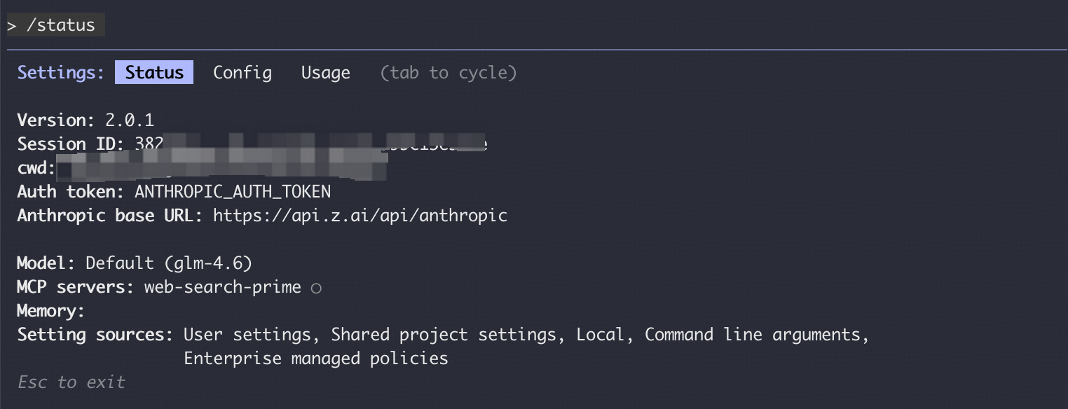
💡 About usage
GLM-5.1 are premium models. During peak hours (14:00–18:00 daily, UTC+8) they draw from your quota at a higher multiplier. Use them when you need the extra horsepower.

Cursor

GLM + Cursor
Cursor speaks the OpenAI protocol, so you'll add GLM as a custom model. The biggest difference from Claude Code: Cursor uses the dedicated Coding API URL.
Could refer to more details instruction: https://docs.z.ai/devpack/tool/cursor
⚠️ Two key points
Custom models require Cursor Pro or higher.
Be sure to use the Coding API URL https://api.z.ai/api/coding/paas/v4 — not the general API.

Step 1 · Get your GLM API Key
Same as the other tools: claim your key from the class Discord GLM group or here: https://zai-hackathon.zeabur.app/
Step 2 · Add a custom model
Open Cursor and go to Settings → Models, click Add Custom Model, and fill in:
- Protocol: select OpenAI.
- OpenAI API Key: paste your GLM key.
- Override OpenAI Base URL:
BASE URL
https://api.z.ai/api/coding/paas/v4
- Model name — type it in UPPERCASE, e.g.
If you want to use better visualize generation model; give a try for GLM-5V-Turbo
MODEL NAME
GLM-5.1 / GLM-5V-Turbo

🔠 Mind the case
Cursor is case-sensitive here: the model name must be uppercase. glm-4.7 will fail; GLM-4.7 works. Other options include GLM-4.5-AIR,GLM-5V-Turbo

Step 3 · Save and switch
Save your settings. Back on the main screen, open the model picker and select your new GLM-5.1 provider so Cursor routes requests to GLM.

Step 4 · Start building
That's it you can now use GLM-5.1 in Cursor for code generation, debugging, and task analysis. Try inline edit (Ctrl / Cmd + K) or the chat panel and confirm you get responses back.

Quick self-check
- Claimed my GLM API Key from the Discord group
- Claude Code: Base URL set to https://api.z.ai/api/anthropic
- Claude Code: running /status shows the model in use
- Cursor: Base URL set to the Coding API (.../coding/paas/v4)
- Cursor: model name entered in UPPERCASE and selected as active

Could refer to more details instruction: https://docs.z.ai/devpack/tool/claude

